

Saint Louis University
Graduate Program, School of Nursing

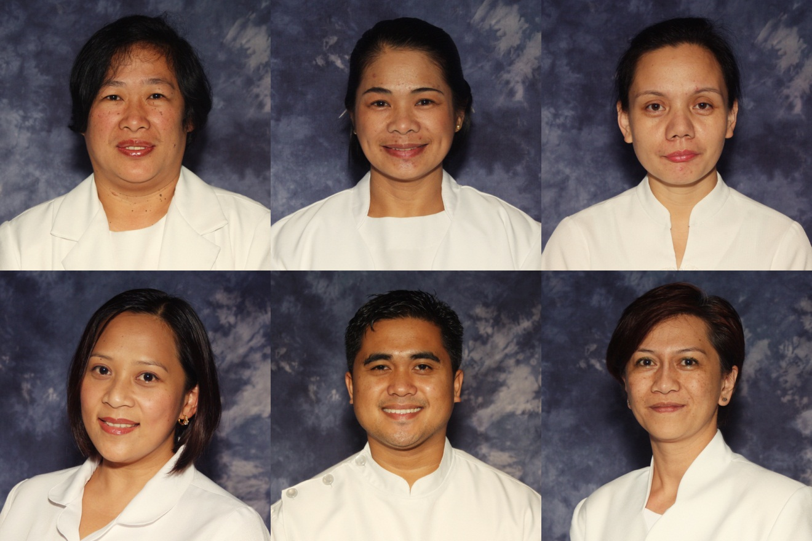

CURRICULUM VITAE

Name: BAUTISTA ELIZABETH Hull
(Family Name) (First Name) (Middle Name)
Date of Birth: Aug. 11, 1969 Place of Birth: BAGUIO CITY Nationality: FILIPINO
Gender: Female Height: Civil Status: 5’4 Name of Spouse: N/A
PRC License No: 0175202 TIN : 138-080-419
SSS No.: 01-0870066-8 Phil Health No.: 04-050016648-9 PAG-IBIG No.: 1290-0054-2218 Baguio Address: 15-A. MARIA BASA STREET, PACDAL, BAGUIO CITY
Home Address: 15-A. MARIA BASA STREET, PACDAL, BAGUIO CITY
Contact Nos: CP No. 091736776635 Land Line: 444-5847
Email Address: bautistaelizabeth0701@gmail.com / jandoyboy@yahoo.com

EDUCATIONAL BACKGROUND: (from ELEM to COLLEGE/POST-GRAD)
LEVEL | SCHOOL | YEAR GRADUATED/  UNITS EARNED | DEGREE
Doctorate | Saint Louis University | Dissertation | Doctor of Philosophy in Nursing
Graduate Studies | University of the Philippines | 2003 | Master of Arts in Nursing, major in Community Health
College Degree | Saint Louis University | 1990 | Bachelor of Science in Nursing
High School Diploma | Saint Louis Pacdal | 1986 | High School
Elementary Diploma | Rizal Elementary School | 1980 | Elementary

WORK EXPERIENCE: (From Present to Past)
YEAR | POSITION | COMPANY/INSTITUTION
Aug 2016-2017 | ON STUDY LEAVE  SLU Ethics Review Committee ember | SLU
2013-Present | Department Head | Saint Louis University
2008-2011 | Graduate Program Coordinator | Saint Louis University
2004-2006 | Department Head
2002 | Project Coordinator, Nursing Clinic | Saint Louis University
1998 | Research Assistant, Malaria Program | University of the Philippines, Manila
1998 | Research Assistant, Curricular Changes | University of the Philippines, Manila
1995 - present | Nursing Faculty | Saint Louis University
1991-1993 | Military Nurse | AFP

PROFESSIONAL ORGANIZATION MEMBERSHIP or AFFILIATIONS
NAME OF ORGANIZATION | POSITION
Philippines Nurses Association | Member
Philippine Nursing Research Society | Member, National Chapter  Vice President, SLU Chapter

RESEARCH INVOLVEMENT
A. FACULTY RESEARCH
DATE | TITLE | SPONSORING AGENCY | ROLE
2015 | Predictive Model Development Towards “Red Tide” Control and Mitigation in Pangasinan Coastal Waters | CHED (awaiting final decision) | Principal Investigator
Aug 2015 | Unstable Families: Prevalence and Behavioral Effects | None | Research Promoter
2016 | Dissertation Topic ongoing: Validity and Reliability of the Braden Risk Assessment Scale: A Two-step Systematic Review | own expense | Primary Investigator
Ongoing  2017 | SLU SON Student Satisfaction Survey | None | Co-Researcher
Ongoing  2017 | Prevalence of Non-Traditional Families in the School of Nursing in School X | None | Co-Researcher
Ongoing  2017 | Lived Experiences of Teenagers from Non-Traditional Family Structures | None | Researcher

B. RESEARCH PRESENTATIONS
DATE | TITLE | SPONSORING AGENCY | ROLE
2013 | Health Disparities: Nurse Academician Role | AEPHONS Seminar, Thailand – Poster presentation - None | Co-Author
2014 | Special Challenges of Diabetic Teenagers | Regional Nursing Research J\Congress – SLU | Promoter

C. PUBLICATIONS
TITLE | JOURNAL/PAPER | DATE
Parenteral Injection Massage: Bioavailability and Adverse effects, A systematic Review | International Journal of Nursing (ISSN 2279-0195), Vol 2, No 1 | 2013
Tug of War: Lived Experiences of Smokers who underwent Bupropion Therapy | International Journal of Scientific and Engineering Research  (ISSN 2229-5518) Volume 5, Issue 8 | 2014

D. OTHER RESEARCH INVOLVEMENT
TITLE | SPONSORING  AGENCY | DATE AND VENUE | ROLE
Adventures of Nursing research: Bridging gaps in Nursing Research  PNRS, Seminar | PNRS | November 29-30, 2013  Crown Legacy Hotel | Organizer,  Scientific Committee Member,  Moderator
PNRS, Seminar | SLU and PNRS | 2014  Crown Legacy Hotel | Organizer, Moderator, Scientific Committee (Screening Committee)
JBL Scientific Session and research Congress  SLU | SLU | 2009-2014  CCA, SLU, | Chairman, 2nd Research Congress, Organizer/Committee Member
Scientific Session | SLU SON and SLU SON Alumni Association | January 17, 2014  CCA | Committee Member
JBL | SLU SON and SLU SON Alumni Association | January 17, 2014  CCA | Committee Member
Integrating the Role of the Nurse Administrator in Critical Care Nursing Challenges (Evidence Based Practice | Saint Louis University School of Nursing Graduate Program | May 17, 2014  Otto Hann AVR | Organizer
16th Regional Nursing research Congress | Saint Louis University School of Nursing | March 5, 2015  Prince Bernhard Hall, SLU | Working Committee
SLU Extension Programs Week | Research and extension Office, SLU with SON and School of Natural Sciences | March 16, 2016  Rizal AVR
17th Regional Nursing Research Congress (Enhancing Nursing Research Competencies Towards Global Competitiveness) | SLU SON with ADPCN | March 23, 2016  Decaestecker Hall, Navy Base Campus, SLU | Working Committee, Facilitator
18th Regional Nursing Research Congress: Upholding Integrity in Research: Principles and Responsibilities in Scientific Writing and Publication | SLU SON with ADPCN | 25 March 2017  CCA, SLU | Scientific Committee Vice Chair, Working Committee, Moderator

EXTENSION AND OUTREACH (Local, Regional, National)
TITLE | SPONSORING  AGENCY | DATE &  VENUE | ROLE
Philippine Nursing Research Society | PNRS | 2012-present | Member
ARI Program | SLU | 2013-present, Buguias, Benguet | Project 2 Leader and Program Member
Philippine Nursing Research Society-SLU Chapter | PNRS | 2013-present | Vice President

SPECIAL TRAINING/S RELATED TO PROFESSION
TILE OF TRAINING | SPONSORING  AGENCY | DATE/VENUE
Training-Workshop on research Ethics for Nurse Researchers (Principles of Good Clinical Practice and Health Research Ethics for Researchers amd Ethics Committee Members) | SLU | October 5-7, 2011  College of Nursing Seminar Room, UP Manila
Evidence-based Nursing | SLU | 2013  Saint Louis University under the US Fullbright Senior Specialist
IV Therapy | None/Self | 2014 SLU Hospital of the Sacred Heart
ICATT IMCI | DOH | 2015 Manila

SEMINARS ATTENDED AS A PARTICIPANT
TILE OF SEMINAR | SPONSORING AGENCY | DATE/VENUE
Evidence-based Understanding of Renal Failure | Saint Louis University, school of Nursing and Alumni Association | Jan 23, 2011  Adenauer 503
Public Hearing on the revised Nursing Core Competency Standards and Public Presentation of the Nursing Law Revisions | PRC Board of Nursing | Jan 17, 2012  Prince Plaza Hotel, Baguio City
Neuroscience Nursing and Research | Philippine Nursing Research Society-CAR | Feb 17, 2012  Supreme Hotel, Baguio
Critical Care Nursing: Evidence Based Practice | Philippine Nursing Research Society-CAR | May 1, 2012
An Introduction to NVivo: A User’s Perspective | Philippine Nursing Research Society | November 24, 2012
Table of Specifications: Test Construction Strategies | Saint Louis University School of Nursing | April 3, 2013  Rizal 601
Enhancing competency in utilizing Health Assessment Tools | Saint Louis University School of Nursing | April 19, 2013  Adenauer 503
Forum on Evidence-based Nursing | Saint Louis University School of Nursing | Sept 6, 2013  Jose Burgos Building, Presidential Board Room, SLU
Preparing for Institutional Evidence Based Practice Implementation | Saint Louis University School of Nursing | September 9-13, 2013  S504
National Tuberculosis Program Orientation for clinical Instructors | DOH | October 23, 2013, Health Services Office, BHD
Understanding Phenomenology and Mixed-Method Research | Philippine Nursing Research Society | Nov 28, 2013  Crown Legacy Hotel, Baguio City
Adventures of Nursing Research: Bridging Gaps in Nursing Research | Philippine Nursing Research Society | Nov 29-30, 2013  Crown Legacy Hotel, Baguio City
Consultative Meeting on the Implementation of the Rules and regulations (IRR) of the K to 12 Law | Saint Louis University | Dec 14, 2013  Gerard Decaestecker Building, SLU Navy Base Campus
International Trends in Nursing Specialties: A closer Look at Nursing Roles and Challenges | Saint Louis University School of Nursing and SLU SON Alumni Association | January 8, 2014  CCA
5th Jesusa B. Lara Lecture Series: Quality Improvement in Nursing | Saint Louis University School of Nursing | Jan 17, 2014  CCA
Role of Nurses in Infection Control and Nurses as Patient Advocate | Saint Louis University School of Nursing | Jan 17, 2014  CCA
Data Gathering in Qualitative Research | Saint Louis University School of Nursing-Graduate School | Feb 14, 2014  Aden 503
Comprehensive Course Evaluation of Nursing Core Competencies | Saint Louis University School of Nursing | February 25, 2014  Adenauer 503
Alternative Interventions for Mental Health | Saint Louis University School of Nursing Graduate Program | April 24, 2014  SLUSHS Palliative Conf Rm
ASEAN Integration 2015, Nursing Core Competencies, Amendments in the Nursing Law, and the Overview of Outcome-based Education | Saint Louis University School of Nursing | June 2-3, 2014  Caba, La Union
Team Building: Strengthening Collegiality and Responsibility | Saint Louis University School of Nursing | June 2-3, 2014  Caba, La Union
Seminar Orientation on Extension Program Guidelines | Saint Louis University School of Nursing | June 5, 2014  Adenaeur 503
Research Proposal Development Seminar | Saint Louis University School of Nursing | June 6-10, 2014  Adenaeur 503
Outcome-based Education in the BSN Curriculum | Saint Louis University School of Nursing | June 13-14, 2014  Adenauer 503
Region I Consultation and Benchmarking Writeshop | Saint Louis University School of Nursing | June 19, 2014  Burgos Bldg Board Room SLU
University Outcomes-based Education Orientation and Program Outcome Development | Saint Louis University School of Nursing | June 4,7,9,2014  Gerard Decaestecker Building, SLU Navy Base Campus
Aligning Nursing Skills with Outcome-based Education | Saint Louis University School of Nursing | August 1-2, 2014  Adenauer 503
16th Regional Nursing research Congress | Saint Louis University School of Nursing | March 5, 2015  Prince Bernhard Hall, SLU
Nursing Scholarship in ASEAN Perspective | Saint Louis University School of Nursing and SLU SON Alumni Association | March 15, 2015  Gerard Decaestecker Conference Hall, Navy Base Campus, SLU
New Trends and Nurse’s Roles in cardiovascular and Renal Nursing | Saint Louis University School of Nursing and SLU SON Alumni Association | March 15, 2015  Gerard Decaestecker Conference Hall, Navy Base Campus, SLU
Integrated Management of Childhood Illness (IMCI) Technical Updates Workshop and Training of Trainors (TOT) Course | DOH, Disease Prevention and Control Bureau | January 12-16, 2015  Richville Hotel, EDSA Crossing, Mandaluyong City
Training Workshop on Health Research Ethics | SLU | March 2-3, 2016,  Alejandro Roces Board Room, SLU
Scaling up Partnerships for Graduate Education and Research | EAFONS and PNRS | February 20-21  Century Park Hotel, Manila

SEMINARS ATTENDED as a Resource Speaker
TITLE OF SEMINAR | TITLE OF SEMINAR | DATE/VENUE
Ethics in Writing and Publication of Research | Saint Louis University-School of Nursing | February 16, 2013  Saint Louis Unversity
TOS and Rubric Development | Saint Louis University-School of Nursing | April 3, 2013  SLU Adenauer 503
IMCI Review | Saint Louis University-School of Nursing | April 3, 2013  Rizal 408
Outcomes-based Education in the BSN Curriculum | Saint Louis University-School of Nursing | June 13-14, 2014  San Fernando, La Union
Qualitative Research | Philippine Nursing Research Society | Sep 13, 2014  Baguio-Benguet Community Credit Cooperative, Baguio City
Outcomes Based Education Integration in the BSN Curriculum | SLU-SON, CHED | November 15, 2014  Adenauer 503
Children’s Health Statistics and Acute respiratory Tract Infection Treatment and Management | DSWD Family Development Sessions | January 2013-July 2015  Buguias, Benguet
Teaching Integrated Management of Childhood Illness Computerized Adaptation and Training Tool | SLU SON with DOH Training Center for IMCI | September 21-25, 2015  Diego 504
Teaching Integrated Management of Childhood Illness Computerized Adaptation and Training Tool | DOH | Series of 6 trainings from 2016-2017 for Benguet, Abra, Aurora Provinces
IMCI Updates: ICATT | PNA-Benguet Chapter | 8 October 2016  La Trinidad Municipal Gym, La Trinidad, Benguet

SUBJECTS TAUGHT
UNDERGRADUATE LEVEL | GRADUATE LEVEL
Introduction to Nursing Research Lecture and RLE | Intensive Practicum in Medical Surgical Nursing
NCM 108 | Entrepreneurship in Nursing
Community Health Nursing | Evidence Based Nursing Practice
Health Assessment Lecture | Clinical Research Methods in Nursing
Health assessment Skills | Ecology, Health and Illness
Pharmacology | Research Methods in Nursing
NCM 102a (IMCI) | Community Health Nursing 1
(NCM106) Medical Surgical Nursing | Medical Surgical Nursing - Adult Health care 1
Nursing Ethics | Comparative Health Care Nursing
Fundamentals of Nursing

